Biosignals2: webcam heart-rate pipeline — how to run it
Oct 7, 2026 · @Carmen Mcclean

What the pipeline does
Each participant ends up with three heart-rate records for the same session, compared block by block: ECG (the ground truth), our webcam analysis (WebcamBiometrics) and FaceReader. The two webcam methods read one and the same video file, so any difference between them comes from the method, not the input.
- ECG: BIOPAC recording, R-peaks and HRV from Kubios. This is the ground truth reference data.
- WebcamBiometrics: our open rPPG code. It finds the pulse in the face colour, frame by frame, using each frame's real capture time.
- FaceReader 10 (Noldus): Noldus Facereader Vital Signs package finds the pulse in the face colour, frame by frame
- Comparison: an R script scores both webcam methods against Kubios in each block (baseline, two inductions, two recoveries) and explains where the errors come from.
Context: The webcam never recorded a continuous video stream. It saved one PNG picture per captured moment plus a spreadsheet of capture times, and the camera's timing is uneven (gaps of 50–175 ms happen). Everything below exists to keep each picture paired with its true time.
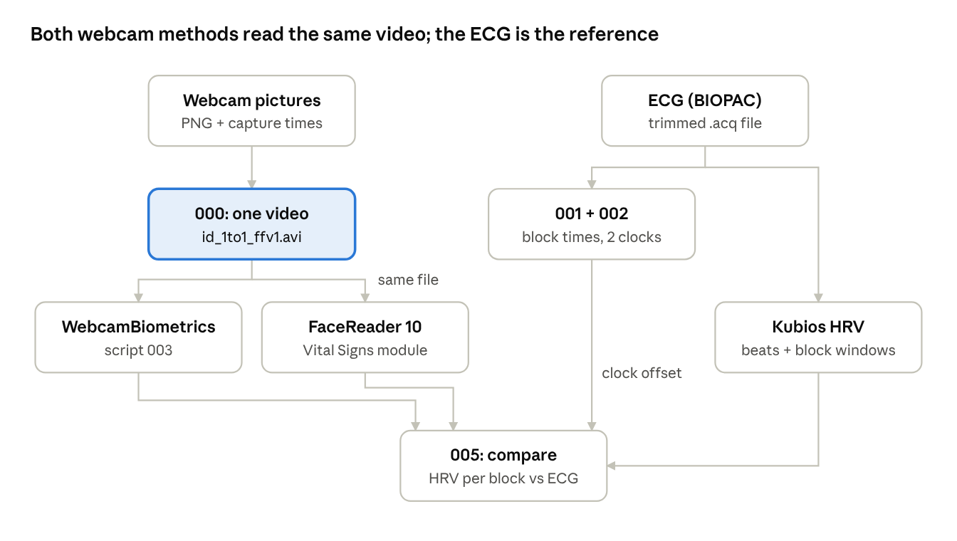
pipeline · 8 steps, one shared video
The webcam pictures become one video that both webcam methods read; the event files line the webcam clock up with the ECG clock, and 005 scores both methods against Kubios.

One-time setup
Everything runs on a Windows PC from PowerShell. Install these once:
What | Why | How
Python 3 with opencv-python, pandas, bioread | Video conversion, event files, webcam export | pip install opencv-python pandas bioread
ffmpeg + ffprobe | Building and checking videos | winget install ffmpeg, then open a new terminal
Node.js LTS | Runs WebcamBiometrics | winget install OpenJS.NodeJS.LTS
WebcamBiometrics packages | Its code and the browser it uses | In the WebcamBiometrics folder: npm install, then npx playwright install chromium
R with readxl | The comparison scripts | install.packages("readxl")
FaceReader 10 with the Vital Signs module | FaceReader's heart rate | Noldus licence

If PowerShell refuses to run npm ("running scripts is disabled"), run Set-ExecutionPolicy -Scope CurrentUser RemoteSigned once.
WebcamBiometrics must be on the branch that contains the face-loss fix (fix/face-loss-gaps, or main once it is merged). It downloads its face model from the internet each run, so the PC needs a connection.
Paths: every script reads its folders from analysis\config.py (Python) and analysis\config.R (R). On a new PC, edit these once: SERVER_ROOT (the Box 3_Data folder), WEBCAM_DIR (the PNG folders), VIDEO_DIR (where videos are written), OLD_WEBCAM_DIR (older sessions' videos) and WEBCAM_BIOMETRICS_REPO (the WebcamBiometrics folder).

Where files live
Raw data and small results live on Box (3_Data); pictures and videos live on the external drive (D:) because they are large and analyses cannot easily be done when they live on an online Box folder. Raw PNG’s and outputs from video analyses are stored on box so that the videos can be reconstructe. <id> is the participant ID, e.g. r2433.
File | Folder | Made by
<id>_frames\frame_000000.png … and <id>_frame_timestamps.csv | D:\Biosignals2_png_data | The experiment (originals; also archived on Box)
<id>_1to1_ffv1.avi + a copy of <id>_frame_timestamps.csv | D:\Biosignals2_video | 000 (or 003 automatically)
<id>_physiology_trimmed.acq | 3_Data\raw_physiology\experimental_protocol_duration | BIOPAC, trimmed to the protocol
<id>_video_events.csv | 3_Data\event_onsets\facereader_video | 001
<id>_events_biopac.csv | 3_Data\event_onsets\webcam_biometrics | 002
ecg_video_offsets.csv (one row per participant) | 3_Data | 003
<id>_webcam_beats.csv, <id>_webcam_hr_events.csv, <id>_webcam_hr_frames.csv | 3_Data\webcam_biometrics | 003
<id>_physiology_trimmed_hrv.csv (Kubios report) | 3_Data\kubios | Kubios, by hand
<id>_detailed, <id>_heart beat log (.xlsx or .txt) | 3_Data\facereader | FaceReader export
<id>_hrv_by_block.csv, _hrv_diagnostics.csv, _hrv_diagnosis.txt, _hrv_plots.pdf | 3_Data\hrv_comparison | 005

All scripts are in Biosignals2\analysis\video, numbered in the order they run: 000_convert_png_to_avi.py, 001_generate_event_onsets.py, 002_create_webcam_events_biopac.py, 003_run_webcam_biometrics.py, 004_convert_mkv_to_avi.py (older participants only), 005_compare_hrv.R, 006_compare_facereader_runs.R. README_convert_png_to_video.md in the same folder explains the video step in detail.

Running it, step by step
Run the steps in this order for each participant. Open PowerShell in the scripts folder first:
cd C:\Users\<you>\...\Biosignals2\analysis\video
- Event times. python 001_generate_event_onsets.py writes when each block started and ended on the webcam clock. python 002_create_webcam_events_biopac.py does the same from the BIOPAC trigger channels, on the ECG clock. Both are needed to line the two clocks up in step 3.
- The video. python 000_convert_png_to_avi.py D:\Biosignals2_png_data --method 1to1 packs every PNG, once and unchanged, into <id>_1to1_ffv1.avi and copies the timestamps file next to it. It skips anyone who already has a video, so an interrupted run can simply be restarted. You can skip this step if you are running step 3 as step 3 makes the video for anyone who doesn't have one.
- WebcamBiometrics. Try 30 seconds first: python 003_run_webcam_biometrics.py <id> --test. Then the whole session: python 003_run_webcam_biometrics.py <id>, or --all for every PNG participant. It reads the video frame by frame (the slow part), finds the heartbeats, works out the ECG→video clock offset from the two event files, prints it, and saves the results in 3_Data\webcam_biometrics. It refuses to continue if the events disagree by more than 50 ms.
- Kubios. (This should already be done from previous analyses, but I have noted it here for completeness sake) Open the trimmed .acq in Kubios HRV, add the five block samples (analysis\kubios\001_create_kubios_samples.py gives their times), keep automatic beat correction, and save the report as CSV to 3_Data\kubios\<id>_physiology_trimmed_hrv.csv. The comparison uses the report's sample windows and RR intervals.
- FaceReader. Analyse the same <id>_1to1_ffv1.avi with the settings in the next section and export its logs to 3_Data\facereader.
- Compare. Rscript 005_compare_hrv.R <id> (or --all). See Comparison analyses below.
Re-running 003 after a code change. --reanalyse redoes only the heartbeat analysis on the frames already read (seconds per participant) this might be used is we have updated some downstream analysis methods; use it after a change to WebcamBiometrics' heart-rate code. --redo re-reads every frame (slow); use it only if the video changed.

FaceReader settings and export
Use identical settings for every participant; differences in settings show up as differences in heart rate.
Setting | Value | Where
Video | D:\Biosignals2_video\<id>_1to1_ffv1.avi | New analysis
Face model | General | Analysis settings
Expression calibration | None | Analysis settings
Vital signs (heart rate, HRV, breathing) | On | File > Settings > Analysis options
Heart rate variability period | 3 minutes | File > Settings > Advanced settings
Frames analysed | Every frame | File > Settings > Video
Export two files per participant into 3_Data\facereader: the detailed log (one row per frame, including the Heart Rate and Heart Rate Variability columns) and the heart beat log (File > Export > heart beat log). Name them <id>_detailed and <id>_heart beat log; the scripts actually identify the participant from the video name written inside each file, so FaceReader's own "Participant 2" names do no harm. Move any older export for the same participant into an archive subfolder first, or the scripts will find two and stop.
Why the .avi and not an .mkv. The same lossless pictures in an .mkv make FaceReader warn "the frame rate / bit rate / resolution is too low" on every frame, because an .mkv doesn't state its bit rate. FaceReader then analyses in a degraded mode: for r2433 it found 24–43% of ECG R-peaks instead of 85–99%. The .avi gives about 4.4 bits per pixel, well above FaceReader's minimum of 0.15.
What FaceReader gives, and when. Heart rate starts after an 8.5 s calibration, and again 8.5 s after the face is lost and found. HRV (RMSSD and SDNN) only appears once the HRV period has passed (first value at 179 s) and each value covers roughly the previous 3 minutes. The 180 s fixation baseline therefore gets a value as long as the recording started before the fixation did.

Comparison analyses

005: HRV per block, webcam and FaceReader against ECG
Rscript 005_compare_hrv.R r2433 s0723
Rscript 005_compare_hrv.R --all
In RStudio, put the IDs in PIDS at the top of the script and click Source.
How it keeps the comparison fair.
- Same windows: every source is cut to the Kubios sample windows (the block start and end times in the Kubios report).
- Same clock: webcam and FaceReader beat times are moved onto the ECG clock with the saved offset. FaceReader's times are first mapped through the real frame timestamps, because FaceReader only knows "frame number ÷ frame rate".
- Same maths: RMSSD, SDNN, pNN50, SD1/SD2, LF/HF and mean HR are calculated by the script for all three sources, the ECG included. Its ECG values match Kubios' own to within 0.7 ms (RMSSD) and 0.8 ms (SDNN).
Versions of each webcam source.
Version | What it is
as_is | The beat intervals exactly as the tool reports them
cleaned | The same intervals after one simple, identical clean-up: drop intervals outside 0.30–2.00 s, drop those more than 20% from the median of their 11 neighbours, drop webcam beats next to a face loss. Removed intervals are not interpolated.
facereader_own | FaceReader's own HRV value at the end of each block, plus its mean heart rate. A secondary measure: Noldus does not publish its filtering.
kubios_report | Kubios' own numbers, kept only as a check on the script

Outputs (in 3_Data\hrv_comparison): <id>_hrv_by_block.csv (every metric, every block, every source), <id>_hrv_diagnostics.csv and <id>_hrv_diagnosis.txt (why each source is wrong, in numbers and in sentences), <id>_hrv_plots.pdf (beat-to-beat intervals of all sources per block, timing errors, missed and false beats), and all_* files that merge everyone run so far, including Bland–Altman agreement.
Reading the diagnosis. For each block and source it reports the pulse delay after the R-peak (normally 100–300 ms; far outside that means the offset is wrong), the share of R-peaks found within ±150 ms, found but further off, or missed, false beats, face-loss gaps, timing wobble, and an RMSSD error split into three parts that add up exactly: missed or false beats, timing noise on beats that were found, and which beats survived. For r2433 and s0723 the webcam's error is mostly timing, not detection.

006: two FaceReader runs of the same participant
Rscript 006_compare_facereader_runs.R <id> <folder with run A> <folder with run B>
It compares the runs frame by frame (heart rate, HRV, confidence, warnings, facial expressions, heart beat log), then scores both against Kubios, block by block and beat by beat. It was used to choose the .avi over the .mkv, and is useful whenever a FaceReader setting changes.

Older sessions and older videos
Sessions recorded before the PNG method (e.g. s0943, e5510, g2313, n2026) have a video recorded straight to <id>_recording.avi plus <id>_frame_timestamps.csv, in OLD_WEBCAM_DIR. Skip step 2: give their IDs to 003 by name (--all only covers PNG participants), and analyse the same <id>_recording.avi in FaceReader. Copy these videos from Box to the external drive first and point OLD_WEBCAM_DIR there; reading them straight from Box was slow and sometimes failed with "Permission denied". Their pictures are compressed (MJPEG), so treat them as a separate group.
Participants converted before 7 October 2026 have <id>_1to1.mkv instead of the .avi. The pictures are the same; only the file wrapper differs. Convert them once, which also deletes each .mkv after checking every frame is identical:
python 004_convert_mkv_to_avi.py --all --delete-mkv
It takes about as long as copying the file (around 5.5 GB per participant). WebcamBiometrics results made from the .mkv stay valid and don't need re-running.

Problems you may hit
Message | Meaning | Fix
npx / npm not recognised | Node.js isn't installed, or the terminal predates the install | Install Node.js LTS, open a new terminal
"running scripts is disabled on this system" | PowerShell blocks npm's script | Set-ExecutionPolicy -Scope CurrentUser RemoteSigned
"Failed to fetch dynamically imported module … vision_bundle" | The face-model download dropped | Run the same command again
Offset refused: events disagree by more than 50 ms | The webcam and BIOPAC event files don't line up | Check both event files for that participant before going on
"… rows but … frames" | The timestamps file doesn't belong to that video | Use the participant's own <id>_frame_timestamps.csv; never a resampled video
"several FaceReader logs, can't choose" | Two exports for one participant | Move the old one into an archive subfolder
"unrecognized arguments" for an option this guide lists | An older copy of the script | Get the current version from the repository

Known limits of the results
- Average heart rate per block is reliable: within about 1 bpm of the ECG for the webcam (r2433 and s0723).
- Beat-by-beat timing is the weak point. Webcam beats wobble ±43–90 ms around the R-peak, so webcam RMSSD is several times the ECG's (cleaned 99–144 ms against 29–41 ms). Treat webcam HRV as not yet usable.
- FaceReader on the .avi finds beats well but still overestimates RMSSD by about 15 ms, because its beat times are tied to the 33 ms video frames.
- Pulse delay differs between people (about 125 ms for r2433, 250 ms for s0723), which is why the scripts estimate it per participant.
- FaceReader's 3-minute HRV window is measured from our files, not documented by Noldus; it still needs confirming with them.
- These figures come from two participants (s0723 has only its two induction blocks). Confirm them as more participants are added.

